
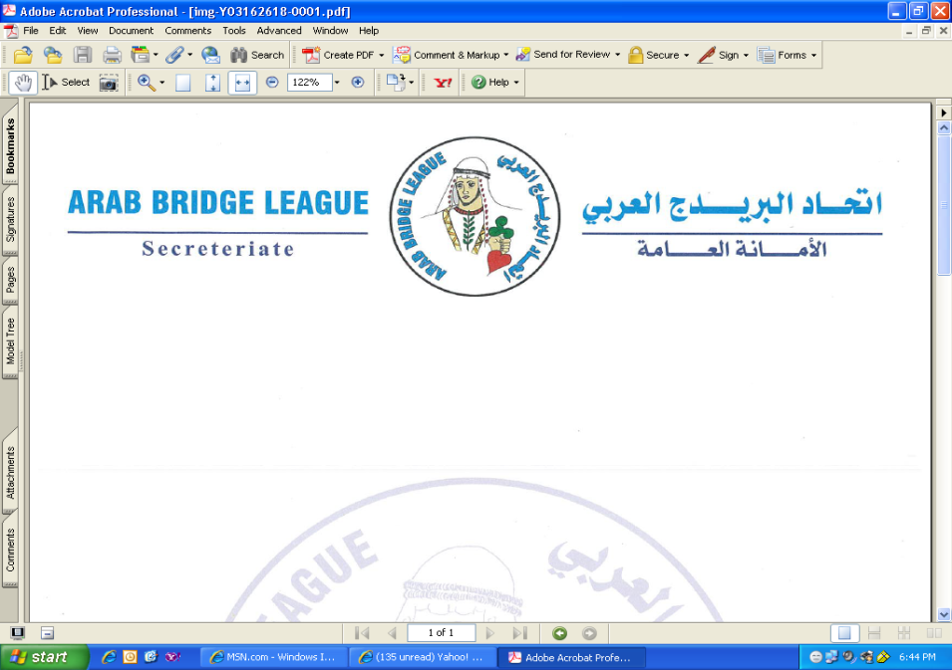


Jordan Bridge Federation

Presents
38th Annual Jordan International Bridge Festival
and the eleventh Pan Arab Inter Club
Under the umbrella of the
Arab Bridge League

October 16^{th.} to 20^{th.} 2019

Bristol Hotel - Amman

PROGRAM OF EVENTS:

Wednesday, October 16th

Pan Arab Inter Club 11:30 am

Reception 06:00 pm
Open Pairs, Session (1) 07:00 pm

Thursday, October 17th

Pan Arab Inter Club 10:30 am
Open Pairs, Session (2) 05:30 pm

Friday, October 18th

Pan Arab Inter Club 10:30 am
Open Pairs, Session (3) 05:30 pm

Saturday, October 19th

Pan Arab Inter Club 10:30 am
Mixed Pairs, Session (1) 05:30 pm

Sunday, October 20th

Pan Arab Inter Club 10:30 am

Mixed Pairs, Session (2) 04:30 pm
Gala Dinner 09:00 pm

Pan Arab Inter club time table is subjected to modifications by
the Organizing Committee according to number of participants.

PRIZES:
OPEN PAIRS Guest (US$) Jordanian (JD)
1st Pair 2000 1000
2nd Pair 1200 600
3rd Pair 800 400
4th Pair 600 300
5th Pair 500 250
6th Pair 400 200
7th Pair 300 150
8^{th,} 9th Pairs 200 100
Best Ladies Pair 150 80
Best Mixed Pair 150 80
Best Improvement 150 80

MIXED PAIRS Guest (US$) Jordanian (JD)
1st Pair 1200 500
2nd Pair 800 300
3rd Pair 600 250
4th Pair 500 200
5th Pair 400 150
6th Pair 300 100
7th Pair 200 100
Best Improvement 100 50

ENTRY FEES:
Event Guest (US$) Jordanian (JD)
Open Pairs 120 45
Mixed Pair 60 30
Pan Arab 400 per team

ACCOMMODATION:
Single room US$ 115
Double room US$ 120
Junior suite US$ 140
Bed and breakfast, all taxes inclusive and free WIFI

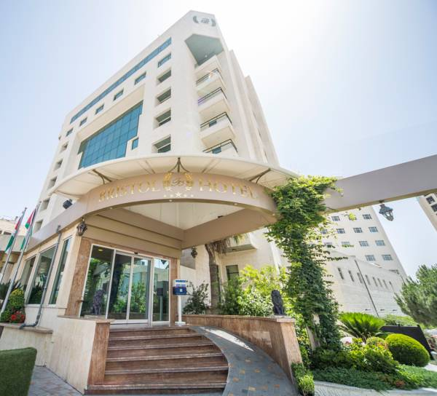
RESERVATION
^{Jordan Bridge Federation}
www. Jordan BridgeFederation.com
^{E-mail: Jor_Bridge@yahoo.com}
Raed Darwish Tel: 00 962796665565 & 00 962 6 5859901 Yazan Al Maridi: Bristol Hotel
^{Tel: 00962798111565}

Egypt: Mrs. May Khoury Tel: 0020 1222108649
Mr. Walid Menyawi Tel: 0020 1288388182
Mr. Amr Askalani Tel: 0020 1001111146

Lebanon: Mr. Nabil Shaker
Tel: 009611352535
E-mail: etsa@cyberia.net.lb
Mr.faycal hamdan tel: 009613231830

Tunisia: Ms. Neila Djamel
Tel: 0021620522521
E-mail: neiladg@hotmail.com

Syria: Mr. Jaen Ghieh
E-mail: jeanghieh@gmail.com

kuwait: Mr: Numan AlTurki Te: 0096599707404

E-mail: namalturki@gmail.com

U.A.E: MR.amr meky: Tel: 00971557718844
E-mail: Amr.mekky@hotmail.com

WWW.JORDANBRIDGEFEDERATION.COM

To check Results and more, just click on: http://www.bridgewebs.com/jordan

